Testing was done using Laravel Dusk, this utilizes a chrome driver to simulate using the webpage and interacting with the elements.

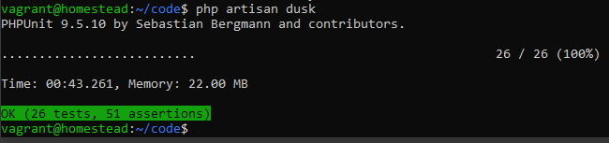

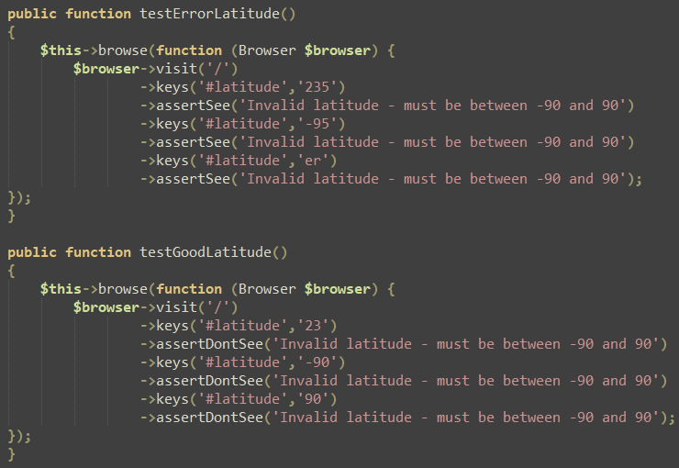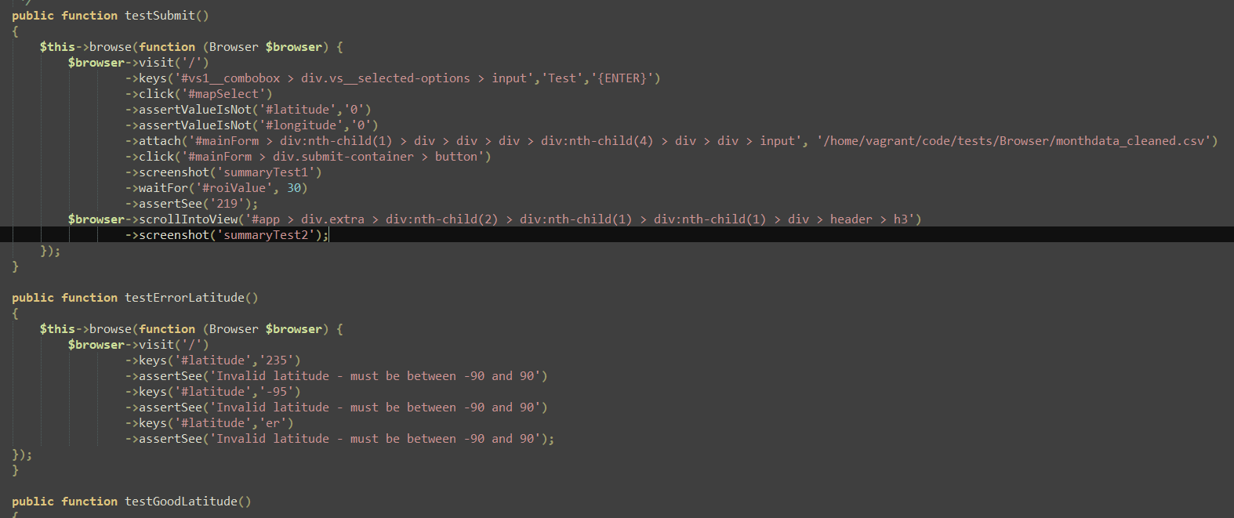

Screenshot from the Laravel Dusk tester

